Secondary Science Method Course

Development
One part of SSTELLA’s intervention consists of preservice teacher participation in a one-semester secondary science method course at each university site that explicitly addresses how science teaching can effectively integrate language and literacy development with inquiry-based science learning. Secondary science method instructors at each university met over a series of face-to-face and virtual meetings to (1) share current instructional approaches, (2) learn from Project PIs about the integration of science learning with language development for ELs (through the SSTELLA instructional practices), and then (3) develop a set of common tools to be used to help preservice teachers experience, analyze, and approximate the SSTELLA instructional practices. Tools includes
- Learning segments: Four multi-day science lessons written with a common coversheet and modeled in class to exemplify the integration of language, literacy, and science through different scientific practices (developing models, arguing from evidence, constructing explanations, planning and carrying out investigations) and different content areas (8th grade physical science, high school earth/space science, high school life science).
- Video cases: Video footage and accompanying discussion prompts that present secondary science teachers enacting SSTELLA practices in their classroom, as well as staging lower levels of SSTELLA implementation for comparison.
- Approximation assignments: Provide opportunities for preservice teachers to rehearse and be coached on particular instructional moves associated with SSTELLA Practices, such as framing a science lesson, facilitating a science talk, engaging in a close reading, and debriefing students’ scientific models.
- SSTELLA Practices Progression: Indicates particular instructional moves associated with the SSTELLA practices at four levels of implementation (no present, introducing, implementing, and elaborating). Used for preservice teacher self-reflection, analysis of video cases and science lessons, and evaluation of preservice teacher implementation in the method course

Guiding Literature
Teaching Practices at the Core
At the core of the method courses was an emphasis on discipline-specific teaching practices that best leverage learning opportunities for a diverse group of students (Grossman & McDonald, 2008; Ball & Forzani, 2009). According to Windschitl, Thompson, Braaten, and Stroupe (2012) these practices would need to be (1) accessible to learners of teaching, even novice ones, (2) applicable to everyday work of teaching, and (3) function synergistically to form a cohort model of teaching and learning – so that instructional approach are grounded in theory of how students learn science. For the project, these practices were grounded in the SSTELLA Framework. To prepare teacher candidates to implement core practices, method instructors engaged preservice teachers in three primary types of activities, represented in Figure 1: experiencing the SSTELLA practices, noticing and analyzing the SSTELLA practices, and then approximating the SSTELLA practices (Abell & Cennamo, 2004; Roth, Garnier, Chen, Lemmens, Schwille, & Wickler 2011; Sherin, 2004). Preparing novices to become reflective practitioners requires that teacher educators help them “hone in on what is important in a very complex situation” (Van Es & Sherin, 2002, p. 573). Videos can be effective as “cases” to develop this ability to notice and analyze teaching practices (Abell & Cennamo 2004; Ash, 2007; Roth et al., 2011; Sherin, 2004). The advantage of videos is that novices can observe teaching in a real-life context (more authentic than a lesson modeled in the method class) with opportunities to “replay” events for further noticing and analysis. Beyond experiencing and analyzing, candidates need opportunities to practice instructional approaches with effective mentoring and support (Joyce & Showers, 1995; Loucks-Horsley, Hewson, Love & Styles, 1998; Speck & Knipe, 2001).

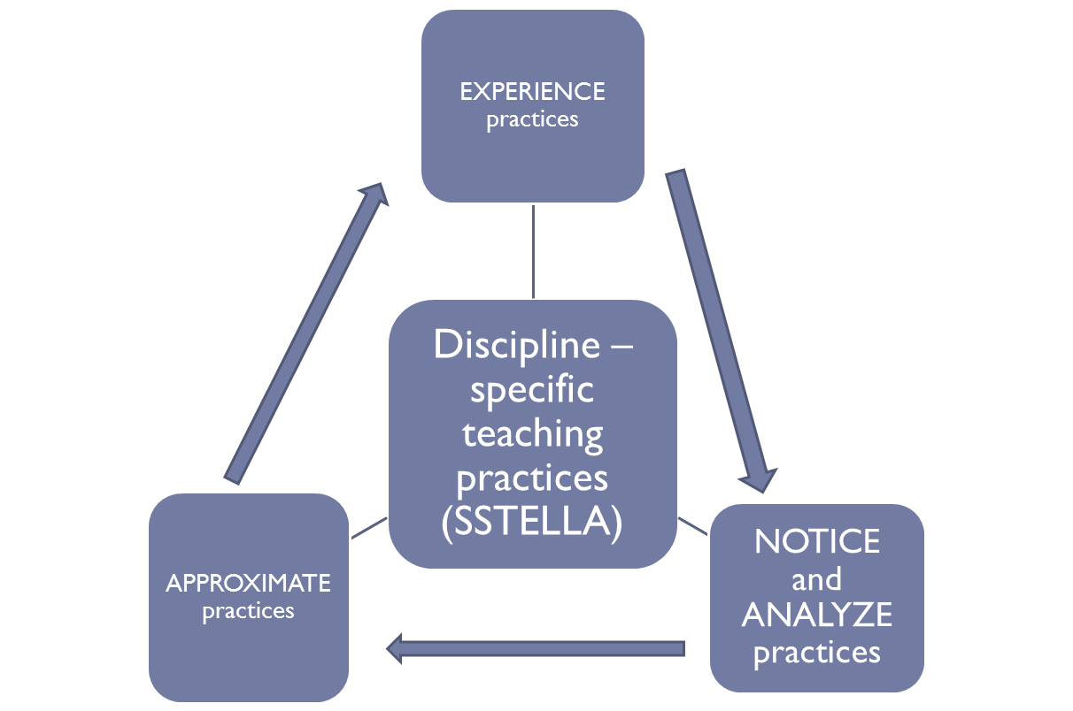
Figure 1. Cycle of “Teacher as Learner”

Implementation
Experiencing SSTELLA Practices through Model Learning Segments
Each method instructor modeled two – four learning segment throughout the course (usually 30-60 minutes of the learning segment). Learning segment modeled various ways to contextualize science activity and integrate language, literacy, and science, but through varied emphases. For instance, the model learning segment, “It’s about Time,” designed for middle school space science, took candidates through the development and use of scientific models with strategies to support the sense-making process (e.g., visual representations, graphic organizers, hands-on materials, etc) while the segment, “Explaining the Antibiotic Resistance of Bacteria,” designed for a high school biology class, focused on helping students use their understanding of natural selection to engage in authentic science literacy tasks, including close readings of various texts and a written evidence-based explanations.
The vignette below describes part of the learning segment, “Explaining the Antibiotic Resistance of Bacteria” as it was experienced in the method course.

Candidates were first shown an anticipatory question:
Recall an experience with hospitals, such as when you (1) were injured, (2) waited for your brother, sister, or cousin being born, or (3) visited a sick family member or friend.
Also think about your own knowledge of hospitals. Do you think someone could be harmed from bacteria while staying in a local hospital? Write your response with a reason in your science notebook.
After writing a response, candidates shared responses with a partner, and then the instructor invited two students to share with the class: a student who responded with “yes” and another student who responded with “no.” A student shared a personal stories about a friend who came to the hospital to get better, only to get sick with something different. The instructor asked follow up questions to the class, such as “do you agree with…” and “what kind of evidence would support our response?” The instructor informed candidates that they will not come to a consensus answer yet, since this real world problem, like most, is complex. However, everything we will be learning in the “upcoming weeks” [if a real high school class] will help us address this question.

At this point, the instructor stopped to do a quick check-in with candidates, asking about the purpose of these first minutes. Candidates had experienced, discussed, and practiced themselves framing instruction through contextualized activities that could connect authentic science to student lives and provide opportunities for student contributions. Thus, candidates readily noticed that what they experienced was intended to bring relevance to the lesson as well as communicate big ideas.

The instructor proceeded to show a short video clip from the url https://www.youtube.com/watch?v=bevhCDOoYeE#t=30 that depicted a newscaster from 2005 reporting on the increased presence of a “superbug” called Methicillin resistant Staphylococcus aureus (or MRSA). The clip ended with a reporter asking an expert: “What causes these so called Superbugs?” The instructor stopped the clip there and stressed to the class that we will exploring this phenomenon ‘What causes Superbugs,” which will help them understand the big idea: “How do species change over time?” The teacher then asked the candidates to use a graphic organizer given to try making sense of some key words, such as antibiotic that were presented in the multimedia text. Candidates completed the worksheet and terms were addressed as a class, with the instructor noting that they will need to use this precise language when explaining what causes superbugs. The instructor then showed an abbreviated timeline that would be revisited later in the unit indicating four key points related to the MRSA “superbug.” The instructor then asked candidates in small groups to create an outline (via a timeline, bulleted list, storyboard, etc.) to provide a tentative explanation about how the species Staphylococcus aureus changed (from 1880s to Present) so that over 60% of the species is methicillin resistant (visuals or charts could help represent “0%” and “60%”). The instructor modeled the process first on a document camera: drawing a picture of a colony of bacteria on a petri dish to represent Staphylococcus aureus and then probes them to consider how we could represent this new “variation” of the species that was identified in 1941 and what words/phrases we could use to describe what happened in between. The instructor posted all students’ initial models on the walls so that students can engage in a “gallery walk” where they view each other’s models. The teacher closed the experience by pointing out the variation in students’ models (both the content and how they decided to represent).

Analyzing SSTELLA Practices
The part of learning segment described in the vignette would have represented the first day of a high school biology unit on natural selection. The instructor informed candidates to put back on their “teacher’s hat” and gave instructors for them to deconstruct this first day of the learning segment from the lens of both scientific practices and potential standards from the Common Core State Standards for English Language Arts (CCSS ELA): Literacy in the Social Sciences, Sciences, and Technical Subjects.

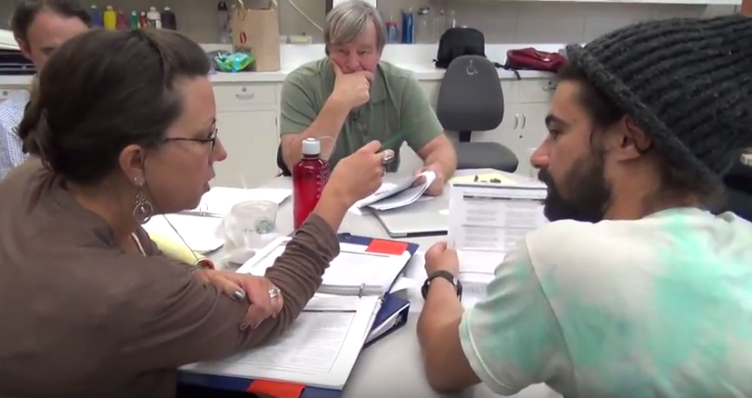
Figure 2. Teacher Candidates Examining Connections Between Common Core Standards and the Modeled “Antibiotic Resistance” Lesson

Candidates had read about and experienced scientific practices, and even incorporated them into their own mini lessons taught in the method course. Thus, they were quickly able to identify “developing and using models” as the primary scientific practice, and also predicted that “constructing explanations” would become a central focus later in the segment. However, this was their first foray into looking at CCSS for ELA in the context of science teaching. The advantage of this particular deconstruct activity was that candidates explored the standards after experiencing a lesson in which the doing of science (e.g., scientific practices) was intimately tied to reading and writing in the discipline of science, so they could directly see overlaps between scientific practices and CCSS for ELA. After discuss what would happen in the upcoming week for the unit, candidates then added another layer of deconstruction by examining an outline of the California ELD Framework (see http://www.cde.ca.gov/ci/rl/cf/elaeldfrmwrksbeadopted.asp), specifically (1) standards related to interacting in meaning ways through collaboration, interpretation, and productive use of language, (2) a document developed by WestEd to connect the ELA/ELD Framework with science content and activities, and (3) descriptions of the new categories of EL proficiency (emerging, expanding, bridging). Finally, the SSTELLA Practices Progression (see excerpt in Figure 3 below) was used to discuss how particular instructional moves might support student mastery of NGSS, CCSS ELA, and ELD standards.

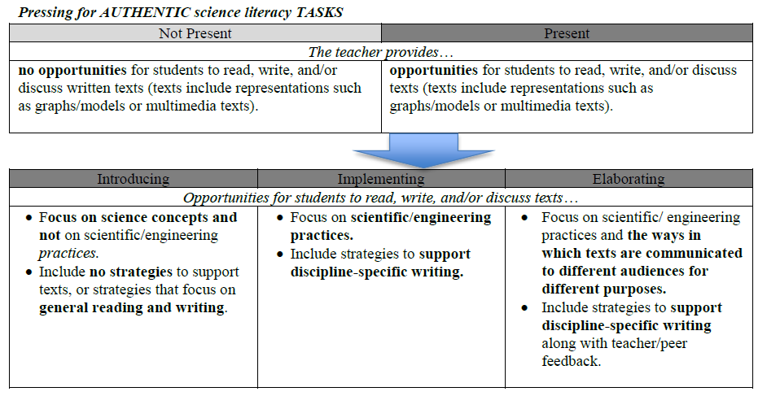
Figure 3. Excerpt from SSTELLA Practices Progression

Analyzing Video Cases
After candidates experienced the last part of the Antibiotic Resistance lesson, they participated in activities to distinguish between two ways of using vocabulary during science instruction. First, they read aloud dialogue from the article by Bruna, Vann, & Perales Escudero (2007). “What's language got to do with it?: A case study of academic language instruction in a high school ‘English Learner Science’ class, which depicted a teacher in a classroom with all EL students focusing on vocabulary fluency and isolated definitions associated with the rock cycle – in effect supplanting opportunities for students to use vocabulary to make sense of the rock cycle. Candidates then watched a video clip related to the vignette of Ms. Bird that was described earlier in the chapter. The video was carried out in a similar schooling context as the one in Bruna et al., but in contrast the teacher supported students’ use of vocabulary through multiple ways as students read texts and eventually developed a class model to depict the chronology of the universe. The video in particular allowed candidates to see and hear interactions between teacher and individual students, which reflected several strategies they experienced in the Antibiotic Resistance Lesson. They were then able to go back to the Antibiotic Resistance lesson and identify various supports and how those supports might be augmented depending on the EL proficiency of students.

Approximating SSTELLA Practices
Candidates were assigned multiple “approximation” assignments. In each approximation, candidates wrote out and then carried out in real time a particular practice indicated in the SSTELLA practices progression: introducing a contextualized big idea, debriefing students’ initial scientific models, using talk moves to facilitate an instructional conversation, and scaffolding an authentic literacy task. For example, one students’ description of the approximation she carried out in class was as followed:

Alright, class we were able to brainstorm and share some of our own ideas of climate change and as a visual for us to use to remember where we began this unit I have assembled a Wordle for us to see the concepts we came up with.
Today we are going to start our exploration of the science behind climate change by doing a jigsaw reading activity. I have found 4 articles that I believe will help us begin to understand the factors that are contributing to the phenomenon of climate change. These articles will introduce us to new key terms and concepts that will help us eventually answer our big question for this unit. “How do human activities influence climate change and in what ways will climate change affect the biosphere?”
I have given each of you a worksheet titled Climate Change Jigsaw with several articles attached to it numbered 1-4. Please write your name and the date at the top of your worksheet (hold up worksheet and indicate where to write this information)

I will first demonstrate how to annotate an article and record key terms and concepts on your worksheet. Please find article #1, titled Global Warming: News, Facts, Causes & Effects, and annotate along with me marking key words and concepts as I go.
Article projected onto board. Teacher reads article aloud, circling key words and underlining key concepts.

Candidates received both written feedback from the instructor as well as oral feedback from instructor and peers directly after approximating the practice. These approximations scaffolded the candidate’s implementation of SSTELLA practices, which then led directly to their culminating product: to develop their own three-day learning segment and teaching 30 minutes from it in class to their peers, being evaluated on the SSTELLA practices. During the first half of the course, each group of four subject-specific candidates (e.g., biology, earth science) was given a specific NGSS and given the task to outline a 10 day unit plan with (1) a central “big idea”, (2) a culminating performance task, and (3) daily learning objectives in addition to the daily classroom activities. Candidates then developed their learning segment from this unit outline.

As evidence by the exemplars and descriptions above, the method course aligned with SSTELLA practices as candidates experienced the practices, analyzed them, and approximated them. Model lessons and videos were key materials to communicate nuances with the SSTELLA practices, how they relate to science and literacy standards, and to depict varying levels of implementing the practices.

References
Abell, S.K., & Cennamo, K.S. (2004). Videocases in elementary science teacher preparation. In J. Brophy (Ed.), Advances in research on teaching: Using video in teacher education (Vol. 10, pp. 103–130). New York, NY: Elsevier JAI.
Ash, D. (2007). Using video data to capture discontinuous science meaning making in non-school settings. In R. Goldman, R. Pea, B. Barron & S. J. Derry (Eds.), Video research in the learning sciences (pp. 207-226). Mahwah, NJ: Erlbaum.
Ball, D. L., & Forzani, F. M. (2009). The work of teaching and the challenge for teacher education. Journal of Teacher Education, 60(5), 497-511.
Bruna, K. R., Vann, R., & Perales Escudero, M. (2007). What's language got to do with it?: A case study of academic language instruction in a high school "English Learner Science" class. Journal of English for Academic Purposes 6, 36-54.
Common Core State Standards for English Language Arts & Literacy in History/Social Studies, Science, and Technical Subjects (Common Core State Standards Initiative, 2010).
Grossman, P., & McDonald, M. (2008). Back to the future: Directions for research in teaching and teacher education. American Educational Research Journal, 45(1), 184-205.
Joyce, B., & Showers, B. (1995). Student achievement through staff development. White Plains, NY: Longman.
Lampert, M., Franke, M. L., Kazemi, E., Ghousseini, H., Turrou, A. C., Beasley, H., ... & Crowe, K. (2013). Keeping it complex using rehearsals to support novice teacher learning of ambitious teaching. Journal of Teacher Education, 64(3), 226-243.
Loucks-Horsley, S., Hewson, P. W., Love, N., & Stiles, K. E. (1998). Designing professional development for teachers of science and mathematics. Thousand Oaks, CA: Corwin Press.
.
National Research Council (2012). A Framework for K-12 Science Education: Practices, Crosscutting Concepts, and Core Ideas. Washington, D.C. : National Academy Press.
Roth, K. J., Garnier, H. E., Chen, C., Lemmens, M., Schwille, K. & Wickler, N. I.Z. (2011), Videobased lesson analysis: Effective science PD for teacher and student learning. Journal of Research in Science. Teaching, 48: 117–148.
Sherin, M.G. (2004). New perspectives on the role of video in teacher education. In J. Brophy (Ed.), Advances in research on teaching: Using video in teacher education (Vol. 10, pp. 1–27). New York, NY: Elsevier JAI.
Stoddart, T., Bravo, M. A., Mosqueda, E., & Solis, J. L. (2013). Restructuring pre-service teacher education to respond to increasing student diversity. Research in Higher Education Journal, 9, 1-14.
van Es, E. A., & Sherin, M. G. (2002). Learning to notice: Scaffolding new teachers’ interpretations of classroom interactions. Journal of Technology and Teacher Education, 10(4), 571-596.
Windschitl, M., Thompson, J., Braaten, M., & Stroupe, D. (2012). Proposing a core set of instructional practices and tools for teachers of science. Science Education, 96(5), 878-903.

